**Software Developer Course Assessment**

**Quantitative Assessment Practice**

**Alex Ewida**

**Course Name: Advanced Programming (Java)**

**Current Week: 15th Jan 2024**

**Submission date: 23rd Jan 2024**

**Introduction:**

The purpose of this assessment is to help us understand how the class is doing in terms of the review material that we have covered during the previous couple of weeks. The **only** purpose of this assessment is for us to improve our approach to review and ensure that what we’re currently doing is an effective strategy. Completion of this assessment is **mandatory - if you don’t submit a solution, it will be marked as incomplete. You must complete a minimum of 80% of your assigned QAPs per course – otherwise you will be marked as incomplete for that course no matter how good your other grades are.** If you do submit a solution, it will be marked as complete, as you will receive full marks no matter what your actual performance was – again this is a participation grade.  
  
Again, the goal here is to help you all in the best way that we can, so please do be honest when answering the questions related to how long it took, which resources you used, etc. And please ensure that you do your **own** work – don't just copy off a friend to get it done, earnestly do your best with it. If you can’t get it completely working, give us what you have. While it will be graded, the grade will not count against you, it’s just a way for us to see where everybody is, and to know which concepts, if any, we, as a class, may be struggling with.

**Deadline:** You will have until the end of the day on 23rd Jan 2024 to submit your assessment solutions. Please ensure you answer all the questions outlined in the instructions portion of this document as well in your submission.

**Marking:** In this program core evaluation is marked with one of three possible marks: *Incomplete, Pass, Pass Outstanding.* For QAPs, though, where incomplete marks are more important for our own information as well as for the information of the student, we wanted to increase the resolution of our grading system. Therefore, QAPs are marked on a scale of 1-5. The details of this marking system are summarized in the table below.

|  |  |
| --- | --- |
| **Grade** | **Meaning** |
| 1 | *Incomplete.* Student shows severe lack of understanding of the material – solution is heavily incomplete, non-functional, or completely off base of what the assignment was asking for. |
| 2 | *Partially Complete.* Students show some understanding of the material. Solution may be non-functional or partially functional, but the approach is correct, albeit with some major bugs or missing features. |
| 3 | *Mostly Complete.* Student demonstrates understanding of the major ideas of the assignment. Solution is mostly working, albeit with a few small bugs or significant edge cases which were not considered. Shows a good understanding of the correct approach, and is either nearly a feature-complete solution, or is a feature-complete solution with some bugs. |
| 4 | *Complete (Equivalent to: Pass.)* Student shows complete understanding of assigned work and implemented all necessary features. Any bugs that are present are insignificant (for example aesthetic bugs when testing the functionality of code) and do not impact the core functionality in a significant way. All necessary objectives for the assignment are completed, and the student has delivered something roughly equivalent to the canonical solution in terms of features and approach. |
| 5 | *Complete with Distinction (Equivalent to: Pass Outstanding)* The student demonstrates a clear mastery of the subject matter tested by the QAP. The solution goes above and beyond in some way, makes improvements on the canonical solution, or otherwise demonstrates the student’s mastery of the subject matter in some way. A solution in this category would consider all reasonable edge cases and implement more than the necessary functionality required by the assignment. |

**Instructions:**

You are allowed to complete the assessment problems below in whatever way you can but please answer the following questions/points as part of your submission:

1. How many hours did it take you to complete this assessment? (Please keep try to keep track of how many hours you have spent working on each individual part of this assessment as best you can - an estimation is fine; we just want a rough idea.)

January.17 – I started working on Problem #1 at 5:00 while watching one of Mrs. Malik’s class recordings and studying the online resources I found. After three hours, I managed to finish building the Account.java file.

Jan.18 – At 11:00am I started building the TestAccount.java file and finished it after 35 minutes. Afterwards, I worked on the Date.java file for Problem 2 from 11:45am to 1:05pm. At 6:50pm I did some changes to Date.java and started working on the TestDate.java file until 8:00pm.

Jan.19 – At 10:00pm I finished my TestDate.Java and started working on my Time.java file. I worked on these until 11:00pm.

Jan.20 – At 9:30pm I continued working on the Time.java until 10:20pm.

Jan.21 – I started working on my projects at 1:00pm. I finished the Time.java file around 1:37pm and then started working on the TestTime.java file and finished it at 2:43pm.

January.22 – At 7:30pm I managed to add all the files to my GitHub page. It took about 5 minutes.

The total amount of time it took for me to finish this project was about 9 hours and 45 minutes.

1. What online resources you have used? (My lectures, YouTube, Stack overflow etc.)

January.17

<https://stackoverflow.com/questions/66437013/how-can-i-update-my-balance-whenever-i-deposit-or-withdraw>

<https://www3.ntu.edu.sg/home/ehchua/programming/java/j3f_oopexercises.html>

January.18

<https://stackoverflow.com/questions/15132693/java-check-file-name-against-current-date>

I watched some of our Java class recordings

<https://www.youtube.com/watch?v=G8_B214NFlM>

January.19

<https://stackoverflow.com/questions/28292359/creating-a-time-class-in-java>

I watched some of our Java class recordings

January.21

I watched some Java class recordings while working on the Time.java and TestTime.java.

1. Did you need to ask any of your friends in solving the problems. (If yes, please mention name of the friend. They must be amongst your class fellows.)

No.

1. Did you need to ask questions to any of your instructors? If so, how many questions did you ask (or how many help sessions did you require)?

I was able to complete it on my own.

1. Rate (subjectively) the difficulty of each question from your own perspective, and whether you feel confident that you can solve a similar but different problem requiring some of the same techniques in the future now that you’ve completed this one.

Building java files for the the three topics was challenging, but with the help of the class recordings and online resources, I was able to complete it on time. The Time.java and TestTime.java files of problem #3 were the toughest.

**Problem#1:**

**The Account Class**

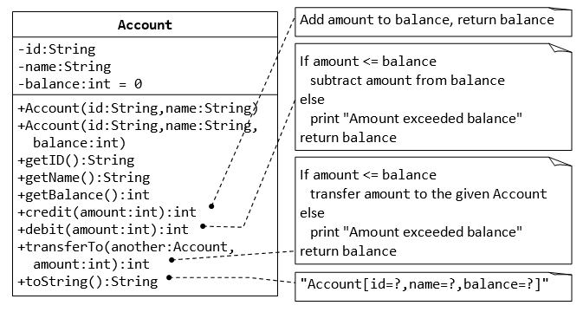

1. Write java code for the Account class explained above. (Account.java)
2. Write a *test program* called TestAccount (in another source file called TestAccount.java) which uses the Account class.
3. Create two accounts
   1. Acc1 with balance of $5000 and Acc2 with balance of $4000 by using parameterised constructors defined in Account class.
   2. Display balance of both accounts using getBalance() method.
   3. Transfer $1000.00 from account 1 to account 2.
   4. Display balance of both accounts using getBalance() method again.

**Deliverable#1:**

*Two complete and working-class files with proper comments.*

1. *Account.java*
2. *TestAccount.java*
3. *Screenshots of the running code’s output*

**Problem#2:**

**The Date Class**

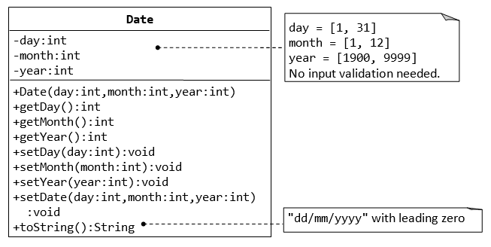

1. Write java code for the Date class explained above. (Date.java)
2. Write a *test program* called TestDate (in another source file called TestDate.java) which uses the Date class.
3. Create a Date object and print it using the toString() method in the format specified.

**Deliverable#2:**

*Two complete and working-class files with proper comments.*

1. *Date.java*
2. *TestDate.java*
3. *Screenshot of the running code’s output*

**Problem#3:**

**The Time Class**

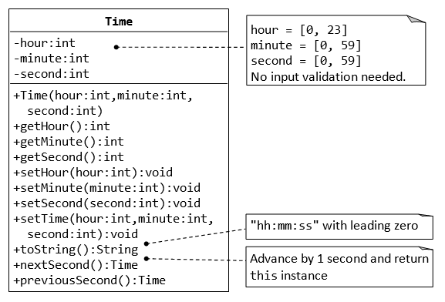

1. Write java code for the Time class explained above. (Time.java)
2. Write a *test program* called TestTime (in another source file called TestTime.java) which uses the Time class.
3. Create a two time objects (t1 and t2). Set their time to 21:10:15 and 10:20:25 using set methods.
4. Call nextSecond() for t1 and previousSecond() for t2.
5. Display the final times for t1 and t2 using toString() method.

**Deliverable#3:**

*Two complete and working-class files with proper comments.*

1. *Time.java*
2. *TestTime.java*
3. *Screenshot of the running code’s output*

**Submission:**

Submit all the 6 java files (Account, Date, Time, TestAccount, TestDate, TestTime) and a word document with the screen shots of all the outputs and their running codes to the assignment area on teams.